**TASK:**

1. Where (to which window) is the output data displayed?

**Output:**

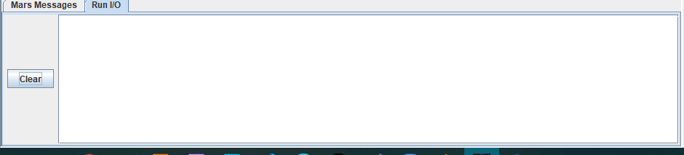

2.Write down the address of the first instruction of the program (see the text window)

**Output:**

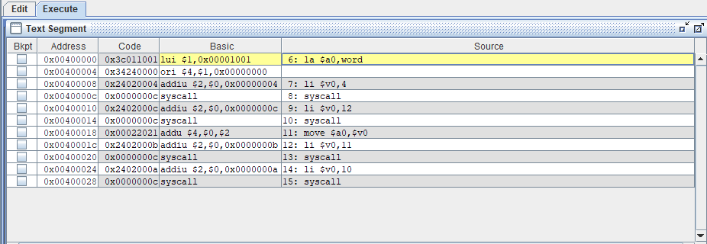

3.Write down the value of the register $sp just before you start the program.

**Output:**

Register of $sp value is 29.



4. Write down the values of $a0 and $v0 after execution in Register window and why?

**Output:**

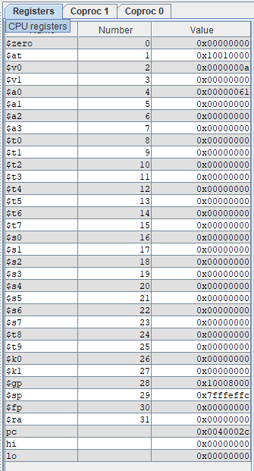

5.Write an assembly program that Read and Print character?

**Solution:**

.data

word:.asciiz "enter the character . \n"

.text main:

la $a0,word

li $v0,4

syscall

li $v0,12

syscall

move $a0,$v0

li $v0,11

syscall

li $v0,10

syscall

**Output:**

